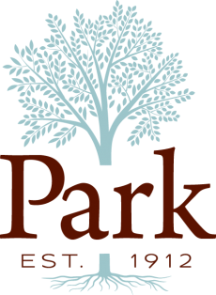
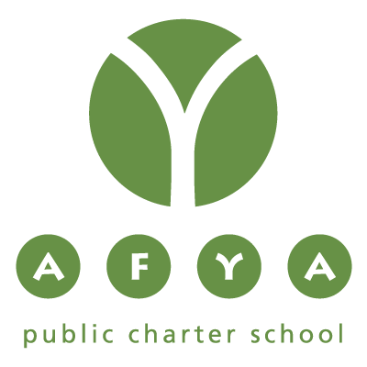
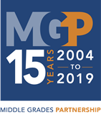

2019 Program Information

What is Middle Grades Partnership?
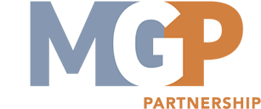
Middle Grades Partnership (MGP) is a rigorous academic program for promising Baltimore City public and private middle school students. The Park School of Baltimore and Afya Public Charter School partnership has been thriving for the last 8 years. MGP serves as a catalyst in addressing inequities in education. The program brings together students, teachers, and leaders from both school communities to collaboratively break down socio-economic barriers in education and our communities by sharing in common experiences and building relationships with peers from both schools. We believe in empowering students to change the trajectory of their lives and of their communities.

What are the benefits of participating?
As MGP scholars, students from Park and Afya come together to further their critical thinking, creative problem solving and academic skills by exploring educational, cultural and social opportunities together throughout their middle school years. By participating in the intensive 5-week summer and the school year program, students will engage in hands-on, project-based, and dynamic learning opportunities while forging new friendships with their Park and Afya peers. The program comes at no additional cost to participating families.
What is the program like?
There is a summer and school year component to the program, with the bulk of the activity and time spent together during the summer.

Summer Program:
The Afya/Park MGP Summer Program includes:
- hands-on, minds-on learning through place-based and project-based learning
- academic enrichment in Science, Arts, Music, Modern Language, with a special focus in Math and Language Arts
- activities such as canoeing, swimming, hiking and Appalachian Challenge course at Park
- student-led “club” activities such as: basketball, volleyball, music, reading, cooking, computers
- field trips to extend our explorations and experiences developed throughout our daily program

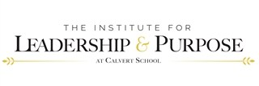
School Year Program (current 7th and 8th grade MGP scholars):

MGP has partnered with The Institute for Leadership & Purpose at Calvert School to create a meaningful leadership series for students to learn about contemporary issues in Baltimore and provide the skills and opportunities to develop as leaders.
In a series of weekend workshops, students will
- participate in team building games;
- learn about leading change and building relationships from guest speakers from Baltimore;
- brainstorm issues, possible solutions and actions, and;
- deepen relationships with their peers through collaboration and problem solving together.

All MGP partnerships will participate in the opening and closing Leadership Summits hosted at Calvert School. Other workshops will be held on site at Afya Public Charter School, transportation to be provided by families.
What is the commitment?
Summer
Dates: June 24th – July 24th 2019, 8:45 am–4:00 pm at Park School (Closed: July 4th -5th)
The MGP program is not limited to just one year. In order to achieve our goal of relationship building through social and academic enrichment, and to support the “cohort” of students, our goal is for our scholars to participate for the 3 years of the program.

Current 6th Grade Scholars will participate over Summer 2019, 2020, 2021, until the completion of middle school.

School Year
School year programming will vary from year to year, but is intended to continue to build relationships between partner schools through leadership development, advocacy and action, and design thinking. More information about the school year programming will be available at the beginning of each year. There will be approximately 4-8 meetings as a partnership, most likely on Saturdays. There will be occasional meetings during or after school as needed that students will need to participate in. If you have prior commitments, we just ask for full communication and transparency of your students’ availability for participation.

Current and prior school year programs include:
- The Institute for Leadership & Purpose with the Calvert School
- “Stories Make the World” with Baltimore Center Stage

What is the cost?
The cost of operating MGP is approximately $1400 per year, per student, however there is no additional cost to participating families.

How do I join?
Complete the student and family interest application (attached). Submissions for consideration of the 2019 Summer are due no later than May 1, 2019. Applications are accepted on a rolling basis until program is full.

Any Questions?
Contact Sarah Howell, MGP Director for Park School of Baltimore at 410-339-7070, ext. 4422 or by email showell@parkschool.net.

For more information about Middle Grades Partnership, please see http://www.middlegradespartnership.org

